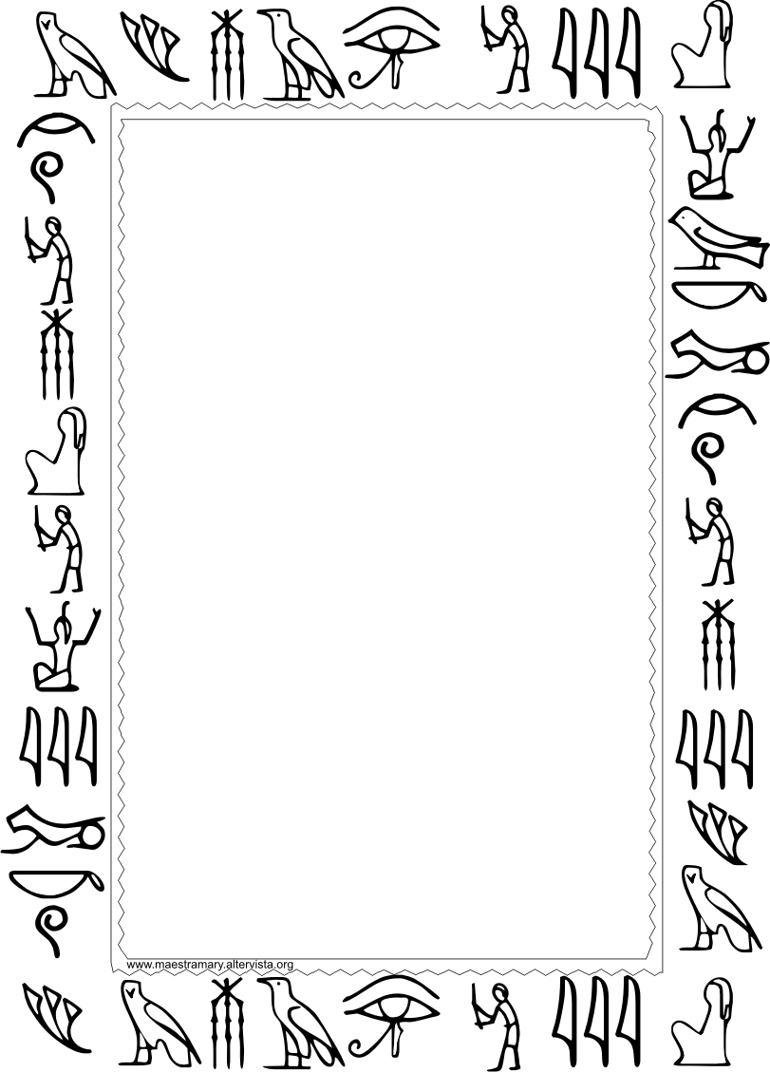

**Choice B: Poster of Museum Layout with Models**

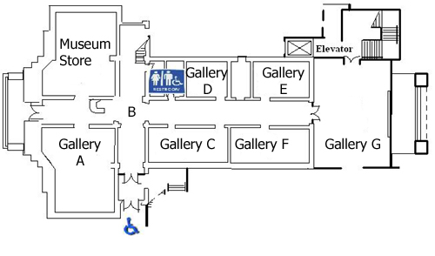

1. **Think of a name for your museum and write it in hieroglyphics at the top center of the poster.**
2. **Draw a LARGE layout of your museum with rooms/topics labeled.**
3. **Make at least 1 model for at least 7 of your chosen topics.**
4. **Have a bag/box to hold your models.**

**Choice C: 3-D Model of Museum**

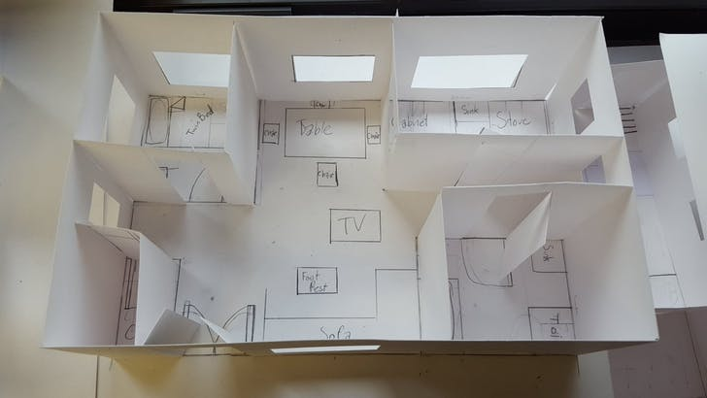

1. **Make a model of the layout of your museum, using cardboard, poster board, or some other sturdy material to create a layout at least 18” x 24”.**
2. **Create walls to divide the rooms and label them.**
3. **Put info and drawn/printed pictures on your walls and at least 3 miniature models abut at least 7 of your chosen topics into the museum.**
4. **Think of a name for your museum and write it in hieroglyphics on the outside of your model.**

**HAVE FUN!!**